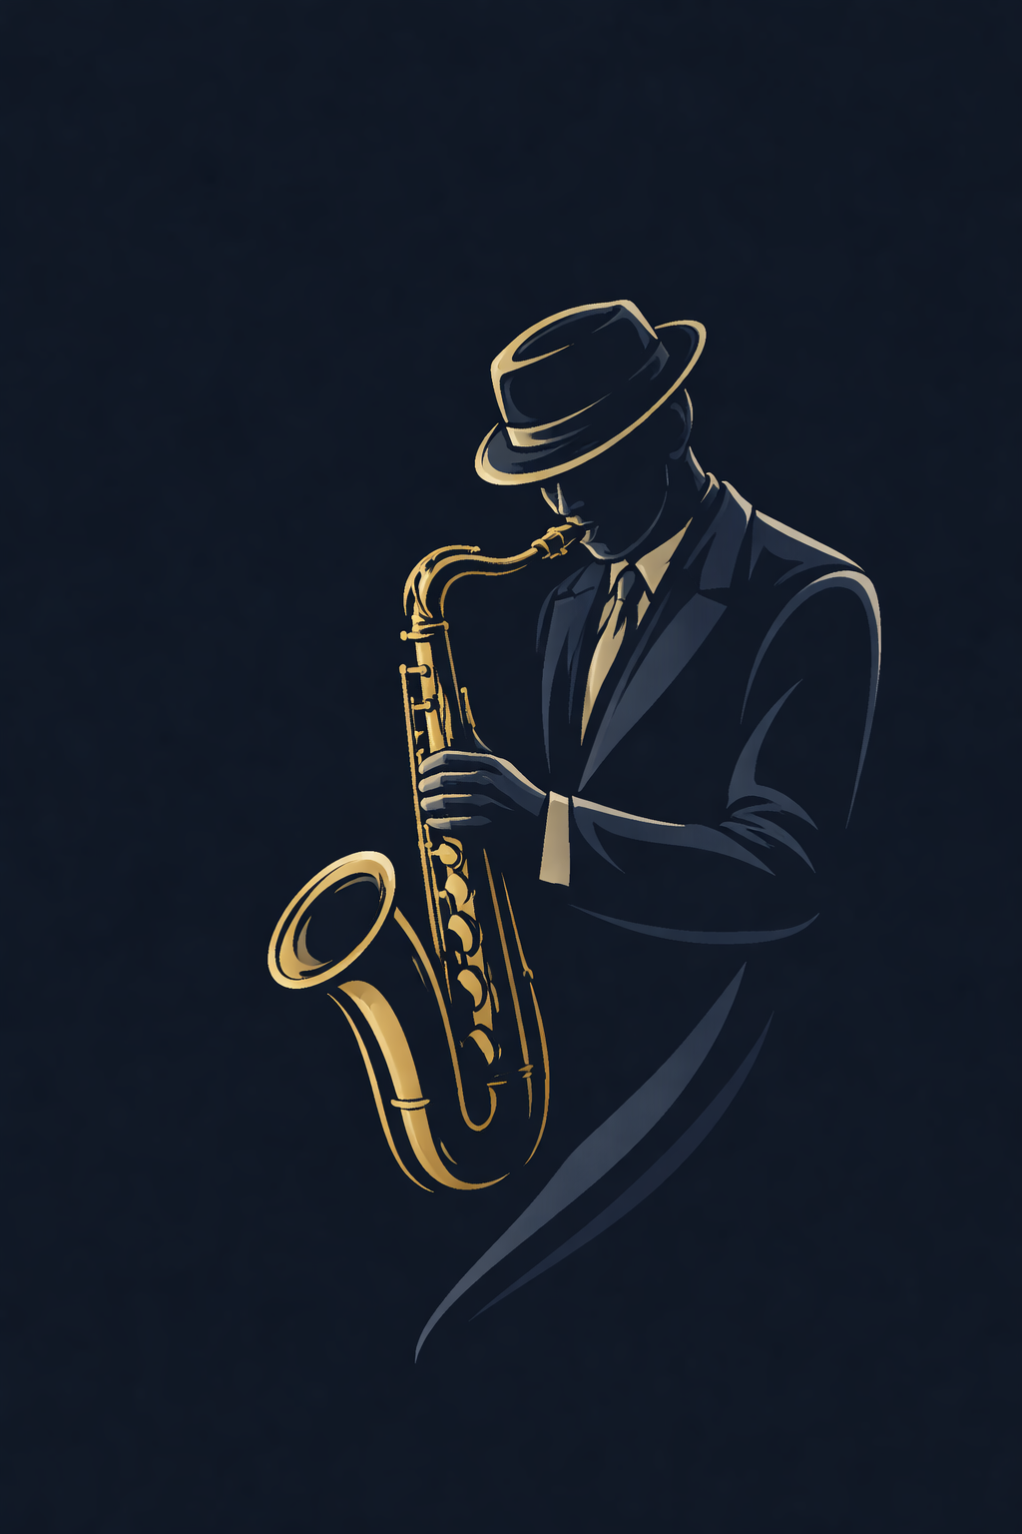

**Prompt :**

Minimalist jazz saxophonist illustration placed on the side of a presentation cover page. Elegant, clean line art with golden and cool gray outlines. The body is filled with deep navy blue tones and subtle shading. Modern, academic jazz aesthetic inspired by late-night jazz clubs. Flat vector style, smooth curves, high contrast, no text, no background elements, refined and calm mood.

**Created With:** ChatGPT 5.0 (background removed with Photoshop)



**Prompt :**

A seamless transition from nature to machine: on the left, a lush forest with evolving wildlife, gradually morphing into glowing, futuristic digital circuits and abstract algorithmic structures on the right, symbolizing evolution from natural processes to computational optimization, soft gradient from green to blue, conceptual, semi-realistic style.

**Created With:** Whisk/ googlelabs

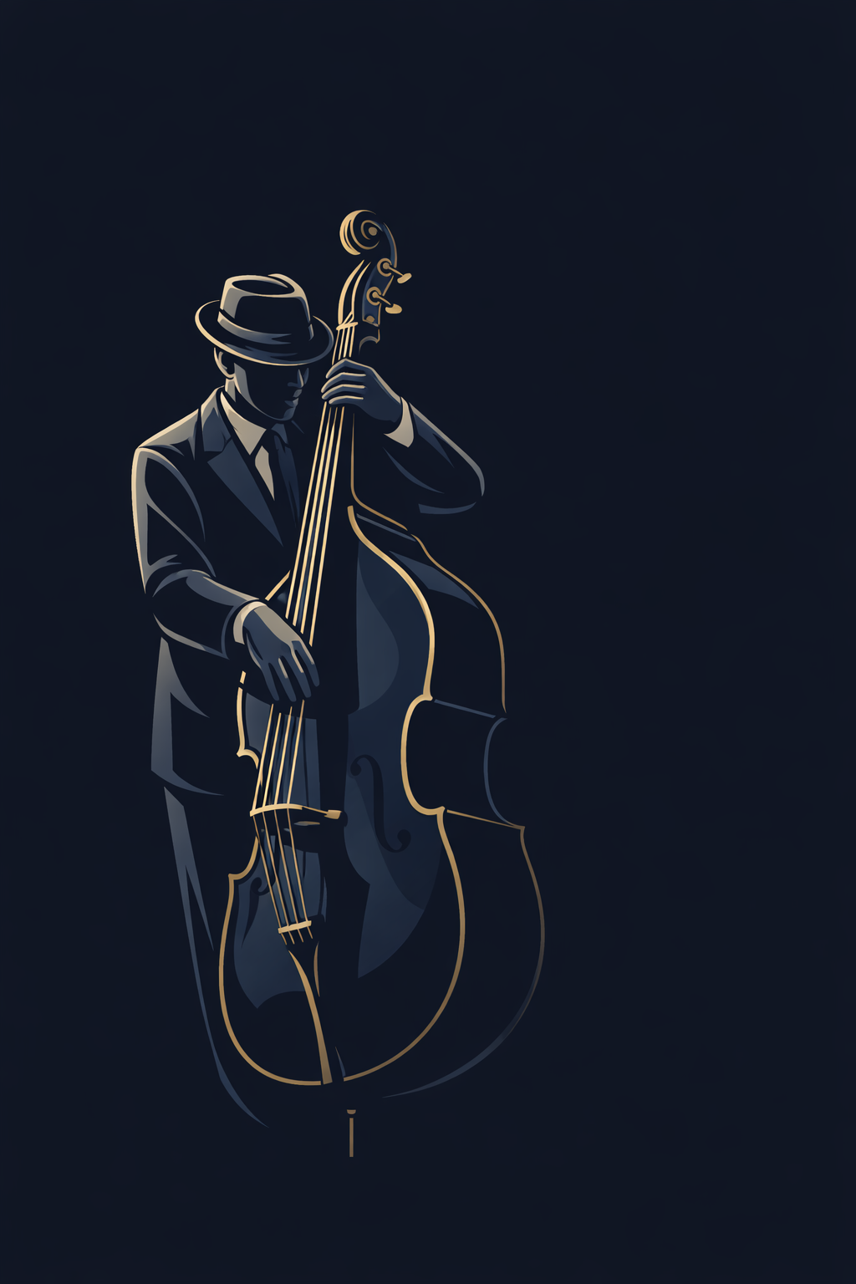

**Prompt :**

Minimalist jazz double bass player illustration, positioned to the side of a presentation cover slide. Clean, elegant line art with muted gold and cool gray outlines. The body is deep navy blue with subtle shading. Flat vector style, modern academic jazz aesthetic, late-night club mood. No text or background clutter. High contrast, refined, calm, intellectual vibe.

**Created With:** ChatGPT 5.0 (background removed with Photoshop)

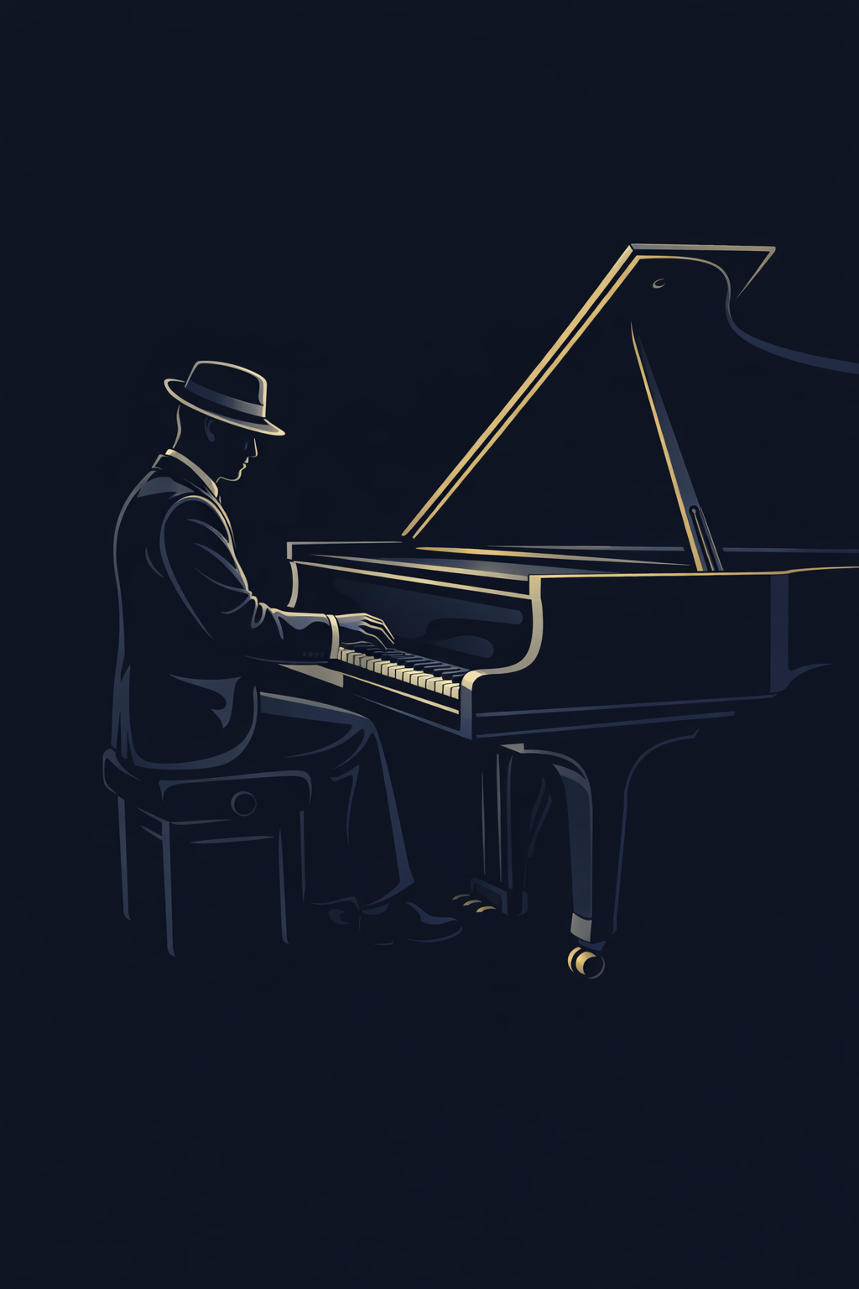

**Prompt :**

Minimalist jazz double bass player illustration, positioned to the side of a presentation cover slide. Clean, elegant line art with muted gold and cool gray outlines. The body is deep navy blue with subtle shading. Flat vector style, modern academic jazz aesthetic, late-night club mood. No text or background clutter. High contrast, refined, calm, intellectual vibe. Minimalist jazz pianist illustration, side view at a grand piano, positioned to the side of a presentation cover slide. Line art with muted gold and cool gray outlines, deep navy blue body and shading. Flat vector, elegant, clean, academic jazz aesthetic, calm and sophisticated mood. No text or background elements. High contrast, smooth curves.

**Created With:** ChatGPT 5.0 (background removed with Photoshop)

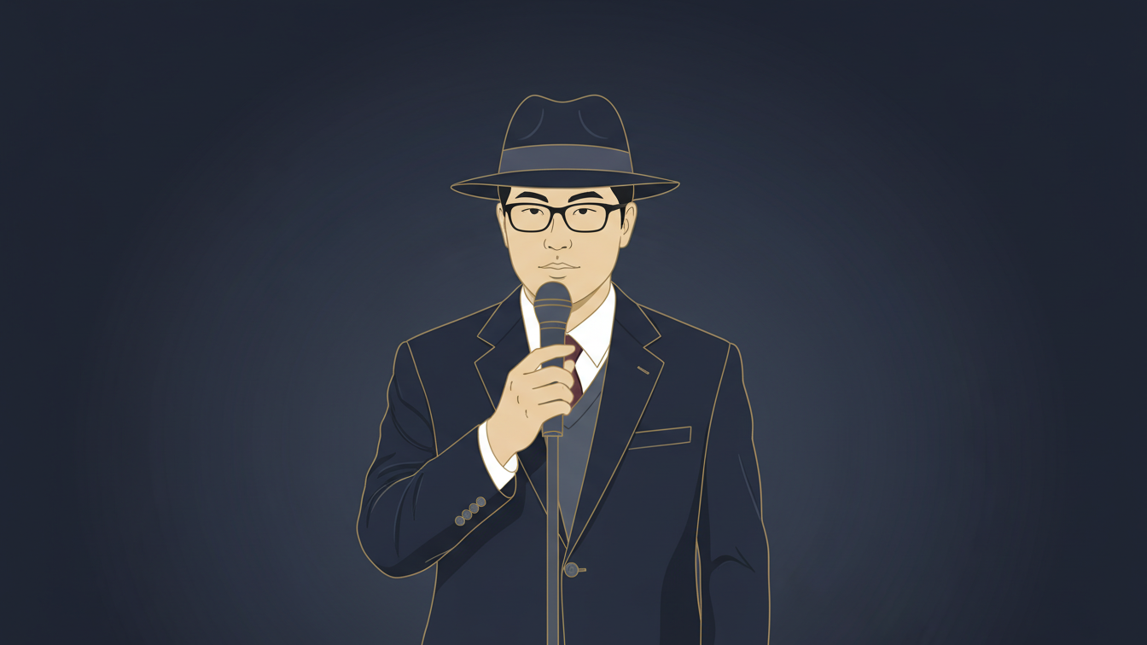

**Prompt :**

Transform the uploaded photo of a person into a minimalist jazz musician illustration, in the same style as a late-night jazz club. The figure should wear a suit and a fedora, holding a jazz singer, holding a microphone. Clean, elegant line art with muted gold and cool gray outlines, body filled in deep navy blue with subtle shading. Flat vector style, high contrast, smooth curves, calm, sophisticated, academic jazz aesthetic. No background clutter, no text, refined and intellectual mood.

**Created With:** Whisk/ googlelabs (background removed with Photoshop)

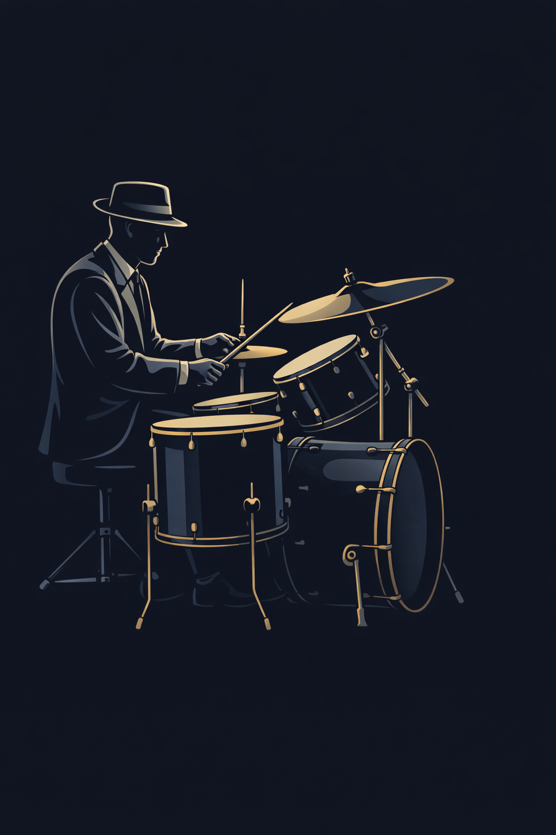

**Prompt :**

Minimalist jazz drummer illustration at a drum kit, side/three-quarter view, positioned to the side of a presentation cover slide. Elegant line art in muted gold and cool gray outlines. Deep navy blue body with subtle shading. Flat vector style, academic and professional jazz aesthetic, clean, calm, high-contrast, no text, no background clutter.

**Created With:** ChatGPT 5.0 (background removed with Photoshop)

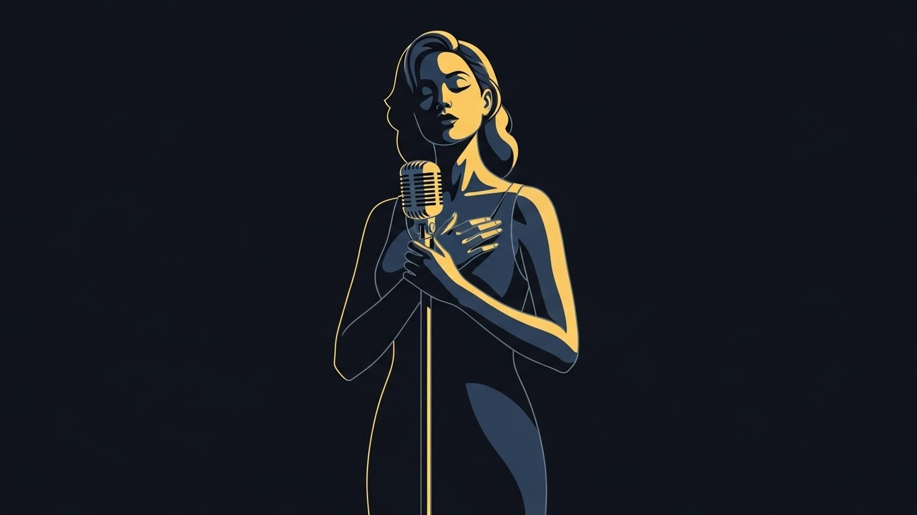

**Prompt :**

Minimalist jazz-inspired illustration representing Harmony Memory Consideration Rate (HMCR) personified as an elegant female jazz vocalist. Calm and confident posture, holding a vintage microphone close to her chest as a symbol of memory and experience. Clean, refined line art with muted gold and cool gray outlines. Deep navy blue body with subtle shading. Flat vector style, academic jazz aesthetic, calm and intellectual mood. No text, no background clutter, high contrast, smooth curve.

.**Created With:** Whisk/ googlelabs (Saxophonist photo image attached, background removed with Photoshop)

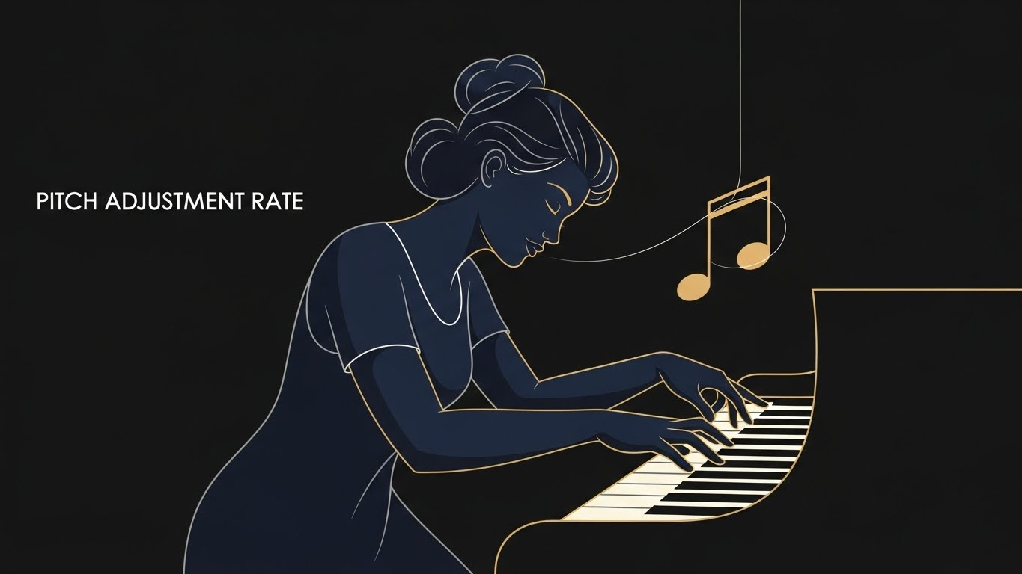

**Prompt :**

Minimalist jazz-inspired illustration representing Pitch Adjustment Rate (PAR) personified as a female jazz improviser. Dynamic yet controlled pose, slightly leaning forward while adjusting piano keys or gently bending a musical note symbol in the air. Elegant line art in muted gold and cool gray outlines. Deep navy blue body with subtle shading. Flat vector illustration, academic jazz aesthetic, expressive but precise mood. No text, no background elements, high contrast, smooth flowing curves.

.**Created With:** Whisk/ googlelabs (Saxophonist photo image attached, background removed with Photoshop)

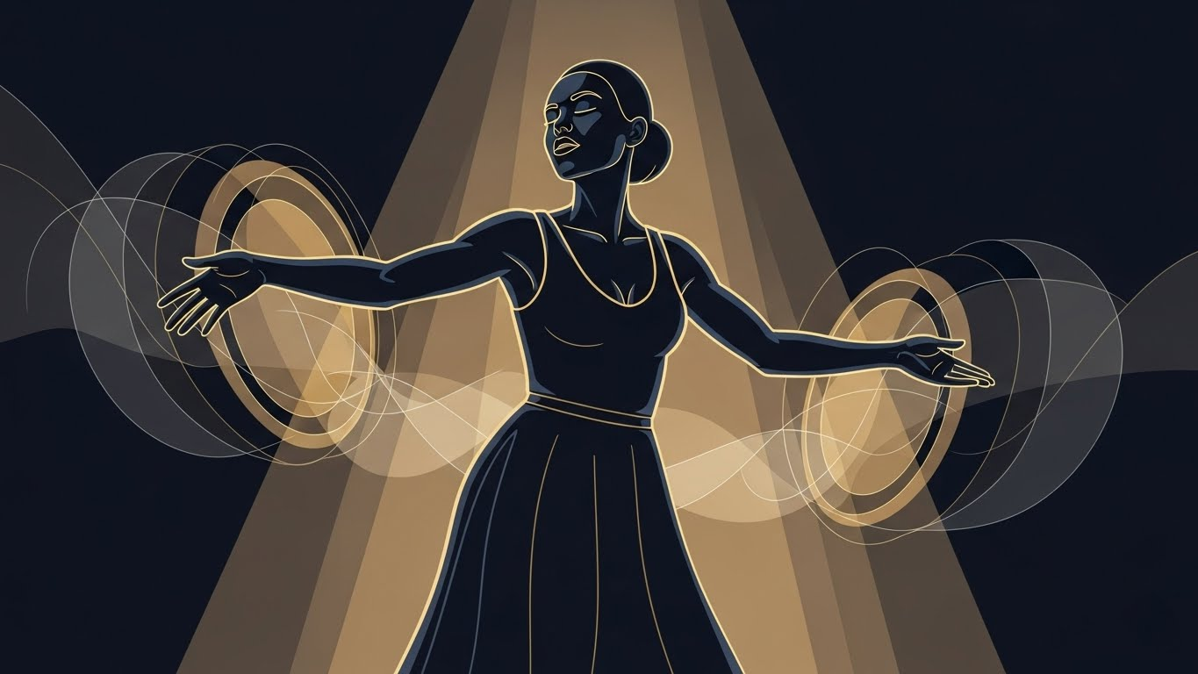

**Prompt :**

Minimalist jazz-inspired illustration representing Bandwidth (BW) personified as a confident female jazz rhythm figure. Open, expansive posture with arms extended, interacting with abstract rhythmic waves or softly glowing drum circles. Clean line art with muted gold and cool gray outlines. Deep navy blue body with subtle shading. Flat vector style, academic and professional jazz aesthetic, sense of controlled freedom and exploration. No text, no background clutter, high contrast, smooth curves.

.**Created With:** Whisk/ googlelabs (Saxophonist photo image attached, background removed with Photoshop)



**Prompt :**

Minimalist jazz-inspired illustration representing the backend of a computational project, personified as a confident female jazz composer and conductor. She stands calmly with sheet music and subtle abstract code symbols, symbolizing structure and logic. Elegant line art with muted gold and cool gray outlines. Deep navy blue body with subtle shading. Flat vector style, academic and professional jazz aesthetic, calm and intellectual mood. No text, no background clutter, high contrast, smooth curves.

**Created With:** ChatGPT 5.0 (background removed with Photoshop)



**Prompt :**

Minimalist jazz-inspired illustration representing the frontend of a computational project, personified as an elegant female jazz performer interacting with abstract visual panels and flowing musical lines. The pose is expressive but controlled, symbolizing user interaction and visualization. Clean line art with muted gold and cool gray outlines. Deep navy blue body with subtle shading. Flat vector style, academic jazz aesthetic, modern and refined mood. No text, no background clutter, high contrast, smooth curves.

**Created With:** ChatGPT 5.0 (background removed with Photoshop)

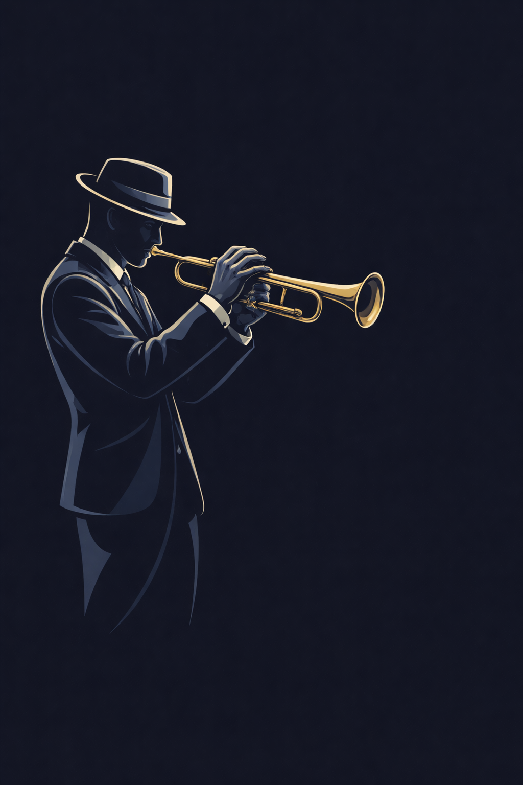

**Prompt :**

Minimalist jazz trumpet player illustration, side view, positioned to the side of a presentation cover slide. Muted gold and cool gray outlines, deep navy body with subtle shading. Flat vector, clean elegant lines, professional academic jazz aesthetic, calm and refined mood. No text or background elements.

**Created With:** ChatGPT 5.0 (background removed with Photoshop)

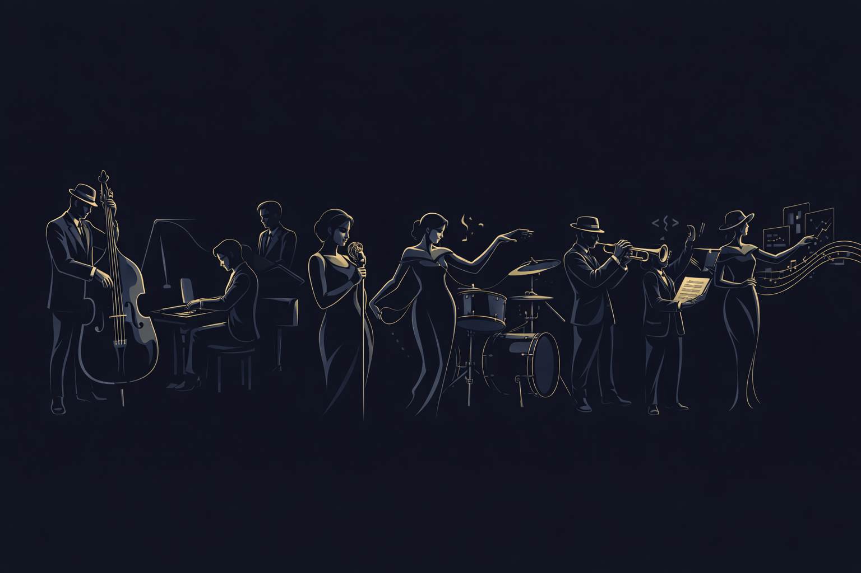

**Prompt :**

Minimalist jazz ensemble illustration featuring all members of a computational project band on the side of a presentation cover slide. Includes:

* **Saxophonist**: smooth, calm posture
* **Double Bass Player**: standing with instrument, elegant
* **Pianist**: side view at grand piano, dynamic yet controlled
* **Drummer**: side/three-quarter view at drum kit, confident
* **Trumpet Player**: side view, refined
* **HMCR**: female jazz vocalist holding a vintage microphone, calm, representing memory and exploitation
* **PAR**: female jazz improviser leaning forward, adjusting piano keys or bending a note, controlled exploration
* **BW**: female rhythm figure with arms extended, interacting with abstract rhythmic waves, exploration range
* **Backend**: female jazz composer and conductor with sheet music and subtle code symbols, structure and logic
* **Frontend**: female jazz performer interacting with abstract visual panels and flowing musical lines, expressive but controlled, user interaction and visualization  
  **Style**: flat vector, minimalist, academic jazz aesthetic

**Created With:** ChatGPT 5.0